**‏ IOT architecture**

“Suggestion ideas for

sugar factory”

The sugar factory goes through many processes, so we will discuss some of the processes. In each operation, we will discuss:

. The steps of the operation.

. The required equipment.

. How to connect these steps with technology?

. In the end, we must have a goal for this process and how to measure this goal.

**Suggested ideas**

1. “**The treatment process”:**

**takes place in two stages, chemical and thermal:**

**-First up is the liming process, where calcium hydroxide is added to the juice. This helps to neutralize acidity and precipitate impurities. After liming, the juice is heated to further precipitate impurities and** create a sludge, which is separated from the clear juice.

**-Next is the carbonation stage, where carbon dioxide is bubbled through the juice. This forms calcium carbonate, which absorbs more impurities. The juice is then heated again to break down the calcium carbonate, leaving behind a purer juice. The purified juice is concentrated by evaporation, forming a thick syrup. This syrup undergoes crystallization, and the sugar crystals are separated from the remaining liquid in a centrifuge. The final step involves drying the sugar crystals.**

**“the Internet of Things (IOT) can be applied to enhance efficiency, monitor processes in real-time, and optimize resource usage”**

* **Sensors for Monitoring Parameters:**

***Temperature Sensors*: Place sensors throughout the processing equipment to monitor temperatures at different stages. This ensures that the thermal treatments are within the optimal range.**

***pH Sensors*: Monitor the acidity of the juice during the liming process to ensure that it falls within the desired range.**

***Flow Sensors*: Track the flow rates of the juice at various points to optimize processing efficiency.**

**protocol for communication [MQTT]**

* **Data Analytics and Machine Learning:**
* **in real-time. Machine learning algorithms can identify patterns and optimize the chemical treatment processes based on historical data. Use data analytics to process information from sensors**

**Predictive maintenance algorithms can anticipate equipment failures, reducing downtime and preventing potential issues in the processing stages. [cloud services]**

* **Remote Monitoring and Control:**

**_Implement IOT devices that allow for remote monitoring and control of the processing plant. This enables operators to keep an eye on the production from anywhere and make adjustments as needed. [cloud services]**

. **Energy Management:**

**_Install energy meters and sensors to monitor energy consumption during the thermal treatment stages. This data can be used to identify areas for energy optimization and efficiency improvements. [cloud services] protocol for communication [ MQTT].**

. **Environmental Monitoring:**

**Install sensors to monitor environmental conditions, such as air and water quality, to ensure compliance with environmental regulations and sustainability goals**

**[cloud services] [COAP]**

. **Integration with Enterprise Systems:**

Integrate IOT data with other enterprise systems, such as ERP (Enterprise Resource Planning) software, to streamline operations, manage inventory, and improve overall efficiency.

"-**2Evaporation process:"**

_In this stage, sugar juice is concentrated and purified. The evaporation unit consists of a set of special metal containers connected to each other by pipelines for transporting sugar cane juice - after it has been purified from impurities and condensed - from one container to another, ultimately producing concentrated sugar cane juice that is free from impurities.

_The juice is purified inside each container by treating it with slaked lime to precipitate a large amount of impurities, which are removed through a special network of pipes. Once the precipitation is complete, steam from the lime and the juice exits through a special opening at the top of the container, and the juice has been thickened into syrup through the boiling of the water used in the evaporation process. It is then transferred to the adjacent container through special pipes. Sometimes, the concentrated juice is purified again, making it ready for the crystallization stage.

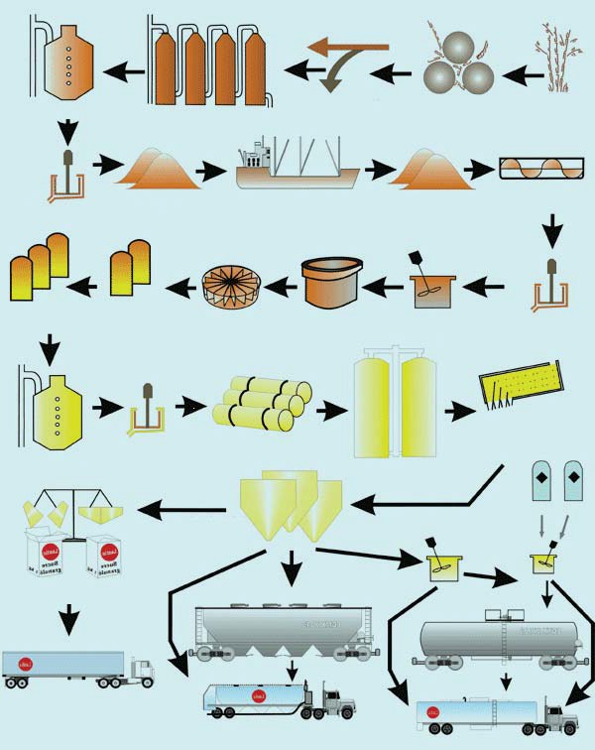

***Machines used in that stage:***

**-1The Evaporation Unit**: This unit typically consists of a set of large metal containers where sugar juice is condensed. This unit also includes equipment for heating the juice and increasing its concentration.

**-2Steam Supply Equipment:** Used to supply steam that is used to heat and concentrate sugar juice inside the containers.

**-3Impurity Removal Equipment:** Lime saturation treatment is employed to precipitate impurities and remove them from the juice.

**-4Juice Transport and Storage Equipment:** Pipes and containers are used to transport concentrated juice from one container to another.

***Problems can be found in that stage:***

**­_Insufficient Precipitation:** If precipitation is not sufficient, some impurities may remain in the juice, affecting the quality of the final sugar.

**_Inhomogeneous Concentration:** Inhomogeneous concentration can occur in the juice, leading to the formation of different layers of sugar and water inside the containers.

***IOT solution Ideas can be implemented:***

1. Top of Form**for the Insufficient Precipitation problem:**

* The overall process details for this issue:

This problem usually occurs in the stage of removing impurities, specifically in the **impurity** **removal device**. This process is typically carried out by treating the juice with saturated lime to precipitate and remove impurities from the juice.

* The devices used in this solution:
* Temperature sensor
* Pressure sensor
* Lime saturation level sensor
* Software for analyzing data from the sensors
* Data storage for long-term
* Alarm device
* How these devices operate and are interconnected?
* **Communication Method:** It is preferred to be wired as it provides reliable, stable, and fast performance.
* **Communication Protocol:** **MQTT** is preferred as it offers efficient and reliable data transmission without data loss.

3- Traditional Sugar Production Process:

_The conventional sugar production process involves various stages, including pressing, where sugar cane is processed to extract juice. This process typically relies on manual monitoring and control, leading to inefficiencies, extended processing times, and increased resource consumption. To address these challenges, integrating Industrial Internet of Things (IOT) technologies into the sugar pressing process can transform it into a smart factory, improving efficiency, reducing processing time, and minimizing resource utilization.

***IOT solution Ideas can be implemented:***

“Real-Time Monitoring and Control System”

**Goal**: Enhance operational efficiency by providing real-time insights into the pressing process.

**Measurement**: Reduce processing time by 15% and achieve a 10% reduction in resource consumption.

**Devices Used**:

1. Pressure Sensors: Installed on pressing machinery to monitor force and optimize the pressing process.

2. Flow Meters: Measure the flow rate of cane juice, ensuring optimal throughput.

3. Temperature Sensors: Monitor the temperature during pressing for efficient heat management.

**Protocol**: MQTT (Message Queuing Telemetry Transport) for real-time communication between sensors and the central control system.

**Reason for Choosing MQTT**: MQTT is a lightweight and efficient protocol, ideal for resource-constrained environments. It enables quick and reliable communication, ensuring that real-time data from sensors reaches the control system seamlessly.